Horror BOOK SUGGESTIONS

TITLE | BLURB | IMAGE | PRICE | ISPN
PICTURE BOOKS
The Skull  By Jon Klassen  6+ | In a big abandoned house, on a barren hill, lives a skull. A brave girl named Otilla has escaped from terrible danger and run away, and when she finds herself lost in the dark forest, the lonely house beckons. Her host, the skull, is afraid of something too, something that comes every night. Can brave Otilla save them both? Steeped in shadows and threaded with subtle wit – with rich, monochromatic artwork and an illuminating author’s note – The Skull is as empowering as it is mysterious and foreboding. | 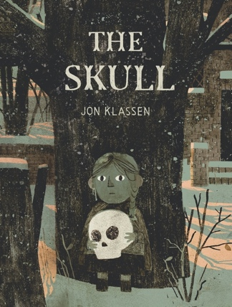 | 32.99 | 9781529509571
The Dark  By Lemony Snickett | Laszlo is afraid of the dark. The dark lives in the same house as Laszlo but mostly it spends its time in the basement. It doesn't visit Laszlo in his room. Until one night it does. With emotional insight and poetic economy, Lemony Snicket and Jon Klassen bring to light a universal and empowering story about conquering fear. Join a brave boy on his journey to meet the dark, and see why it will never bother him again. | 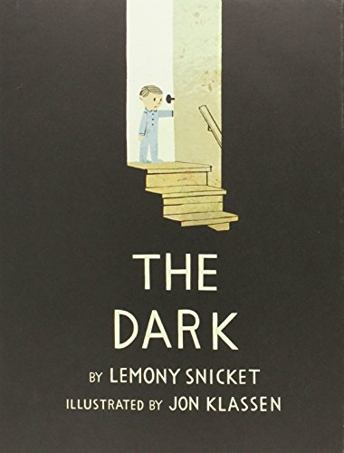 | 15.99 | 9781408330036
There’s a Ghost In this House  By Oliver Jeffers | A captivating new picture book with interactive transparent pages, from world-renowned artist Oliver Jeffers.  Hello, come in.  Maybe you can help me?  A young girl lives in a haunted house, but has never seen a ghost. Are they white with holes for eyes? Are they hard to see? She’d love to know! Step inside and turn the transparent pages to help her on an entertaining ghost hunt, from behind the sofa, right up to the attic. With lots of friendly ghost surprises and incredible mixed media illustrations, this unique and funny book will entertain young readers over and over again! | 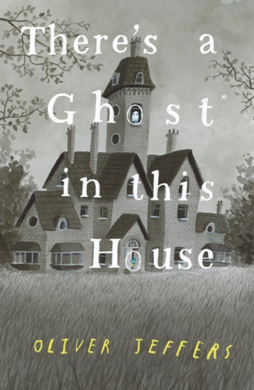 | 29.99 | 9780008298357
MIDDLE GRADE
Hush-A-Bye  By Jody Lee Mott | Like most kids with younger siblings, Lucy loves her sister Antonia, but is all too frequently annoyed with her as well. The two spend most of their time together since their mother works so hard, but without friends Lucy can't help but feel lonely anyway. She's always tried to ignore the bullying and teasing at school about her family being poor--it's always best to keep her head down and do nothing.  When the girls find an old, muddy doll head in the river, Antonia claims it as her newest treasure. At night Lucy hears her talking to Hush-a-Bye--and does she hear the doll talking back? Soon, Hush-a-Bye seems to be protecting Antonia by making bad things happen to others, and it isn't long before Lucy asks for its help against her tormentors, too. Slowly Hush-a-Bye's influence forms a wedge between the sisters, and Antonia's dependence on it becomes frightening. The doll has a mind of its own, and soon it will have Antonia's as well. Can Lucy solve the mystery of Hush-a-Bye to stop its evil plans? | 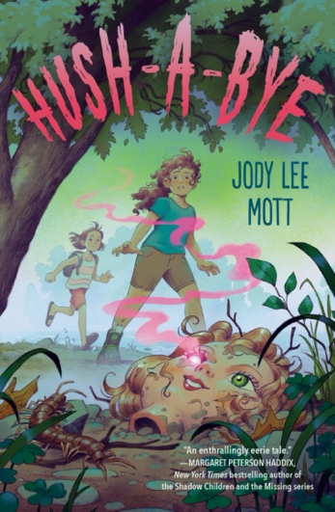 | 14.99 | 9780593206799
Ghost Book  By Remy Lai | Twelve years ago, the boy and the girl lived. But one was supposed to die ...  July Chen sees ghosts. But her dad insists ghosts aren't real. So she pretends they don't exist. Which is incredibly difficult now as it's Hungry Ghost month, when the Gates of the Underworld open and dangerous ghosts run amok in the living world. When July saves a boy ghost from being devoured by a Hungry Ghost, he becomes her first ever friend. Except William is not a ghost. He's a wandering soul wavering between life and death. As the new friends embark on an adventure to return William to his body, they unearth a ghastly truth - for William to live, July must die.  Inspired by Chinese mythology, this resoundingly hopeful tale about friendship, sacrifice and the unseen world of ghosts is a dazzling heir to beloved Studio Ghibli classics. | 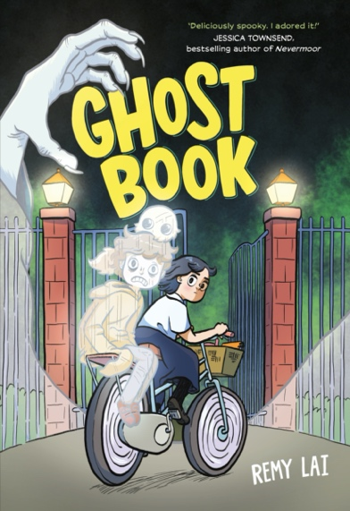 | 19.99 | 9781761065477  AUG/SEPT
The Haunting of Aveline Jones  By Phil Hicks | Turn on your torches and join Aveline Jones!Aveline loves reading ghost stories, so a dreary half-term becomes much more exciting when she discovers a spooky old book. Not only are the stories spine-tingling, but it belonged to a girl called Primrose Penberthy, who vanished mysteriously, never to be seen again. Intrigued, Aveline decides to investigate Primrose’s disappearance, with some help from her new friend, Harold. Now someone…or something, is stirring. And it is looking for Aveline.The first in a deliciously spine-tingling, spooky new series, where mysteries are always solved, spirits are always laid to rest, and everybody gets to bed on time. Perfect for adventurers aged 9+ | 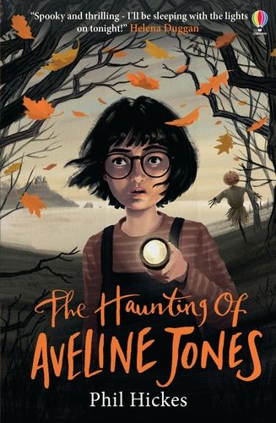 | 14.99 | 9781474972147
The Witching Hours  By Jack Henseleit  6 book series | A storm is raging around the forests of Transylvania, where siblings Anna and Max are visiting with the Professor. Left alone to explore a creepy old inn, the children discover that something evil is lurking in the trees – and it just might have a taste for human blood.  When Max goes missing, it’s up to Anna and her new friend Isabella to rescue him. Setting out in the dead of night, with the storm howling around them, the girls will face peril after peril. Only one thing is certain: even if Anna can find a way to rescue her brother, Max will never be the same again …  The Vampire Knife is the first book in The Witching Hours, a spine-tinglingly spooky new series by Jack Henseleit for readers 8+. | 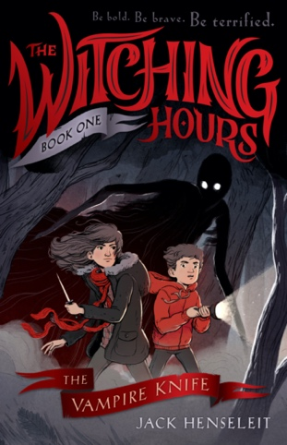 | 17.99 | 9781760129255
Hell Breaks Loose  By Derek Landy | Discover the world of Skulduggery Pleasant in this prequel to the bestselling series. So many enemies, so little time . . .  Italy, 1703.  As the war with Mevolent rages on, the Dead Men are dispatched to a walled town in the Tuscan hills – not to assassinate the Lord of the Dark Sorcerers, but to save him. A rift has opened to a hellish dimension where a being of devastating power awaits, and only Mevolent is strong enough to seal it and save the world.  A simple mission, then, which turns ever-so-slightly trickier when Skulduggery is presented with the opportunity to finally get revenge on Nefarian Serpine, the man who murdered him and killed his family thirteen years earlier. | 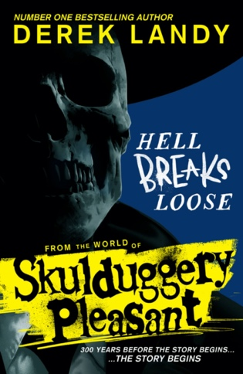 | 19.99 | 9780008586034
Sinister Summer Series  Bk1 Wretched Waterpark  Bk2 Vampiric Vacation  Bk3 Camp Creepy – Kiersten White  By Kiersten White | A middle-grade mystery series that’s spooky, creepy, and filled with gothic twists!  Meet the Sinister-Winterbottom twins, who solve mysteries at increasingly bizarre summer vacation destinations in the hopes of being reunited with their parents-or at the very least finally finding a good churro. | 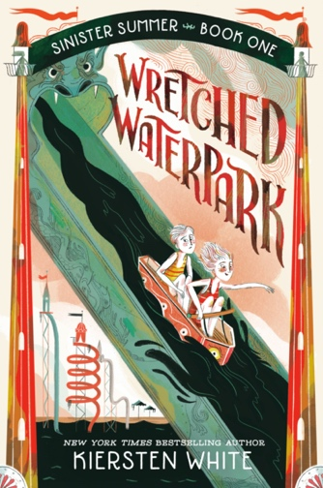 | 16.99 | 9780593572580  9780593644904  9780593650264
The Glow  By Sofie Laguna | Megan is obsessed with drawing fantastical creatures and she shares them with her best friend Li who writes stories to go with the pictures. They are kindred spirits with big creative dreams.  One day everyone in town – except Megan and Li – is immobilised by a strange glow coming from their phones. Megan and Li are initially frightened and alarmed, but when they realise they are somehow immune, they set out to seek help.  Soon a battle unfolds, a thrilling battle that pits all of their creative energies against the terrible monster that has ensnared everyone else around them. | 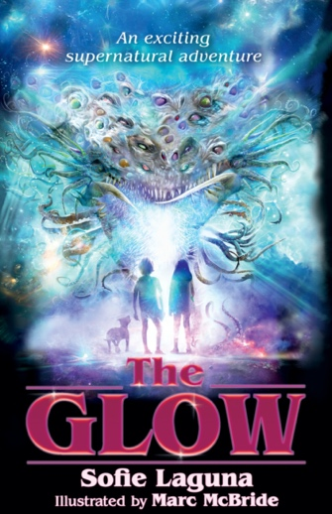 | 16.99 | 9781761066825
No Place For Monsters  By Kory Merritt | Nothing is out of place in the quiet suburban town of Cowslip Grove. But kids have been going missing – and only Levi and Kat have noticed. It’s up to them to save the missing kids before a hidden evil swallows the town whole | 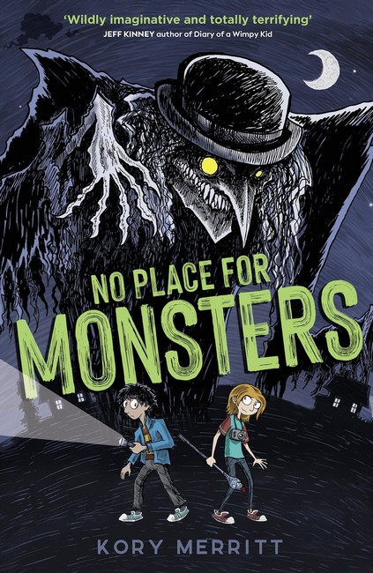 | 18.99 | 9781913696085
The Stars Did Wander Darkling  By Colin Meloy | Maybe Archie Coomes has been watching too many horror movies.  All of a sudden, the most ordinary things have taken on a sinister edge: a penny on a doormat. A man in a brown suit under a streetlamp. The persistent sound of an axe chopping in the middle of the night.  He keeps telling himself that this is Seaham, a sleepy seaside town where nothing ever happens. Or at least nothing did, until his dad’s construction company opened up the cliff beneath the old – some say cursed – Langdon place.  Soon, though, he and his friends can’t deny it: more and more of the adults in town are acting strangely. An ancient, long-buried evil has been unleashed upon the community, and it’s up to the kids to stop it before it’s too late . . . | 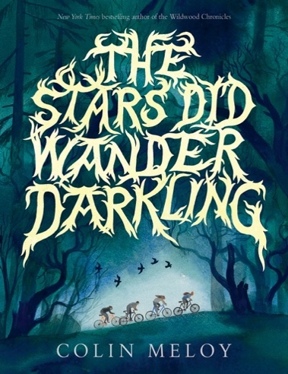 | 17.99 | 9781760657192
The Clackity  By Lora Senf | Evie Von Rathe lives in Blight Harbor—the seventh-most haunted town in America—with her Aunt Desdemona, the local paranormal expert. Des doesn’t have many rules except one: Stay out of the abandoned slaughterhouse at the edge of town. But when her aunt disappears into the building, Evie goes searching for her.  There she meets The Clackity, a creature who lives in the shadows and seams of the slaughterhouse. The Clackity makes a deal with Evie to help get Des back in exchange for the ghost of John Jeffrey Pope, a serial killer who stalked Blight Harbor a hundred years earlier. Evie reluctantly embarks on a journey into a strange otherworld filled with hungry witches, penny-eyed ghosts, and a memory-thief, all while being pursued by a dead man whose only goal is to add Evie to his collection of lost souls. Will she ever find Des, or is The Clackity planning something far more sinister? | 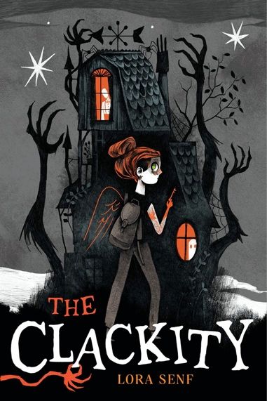 | 29.99 | 9781665902670  Paperback due Aug
Dust & Grim  By Chuck Wendig | Thirteen-year-old Molly doesn’t know how she got the short end of the stick-being raised by her neglectful father-while Dustin, the older brother she’s never met, got their mother and the keys to the family estate. But now the siblings are both orphaned, she’s come home for her inheritance, and if Dustin won’t welcome her into the family business, then she’ll happily take her half in cash. There’s just one problem: the family business is a mortuary for’monsters, and Molly's not sure she's ready to de’l with mysterious doors, talking wolves, a rogue devourer of magic, and a secret cemetery. It’s going to take all of Dustin’s stuffy supernatural knowledge and Molly’s most heroic cosplay (plus a little help from non-human friends) for the siblings to figure it out and save the day…if only they can get along for five minutes.  Bestselling author Chuck Wendig’s middle grade debut is equal parts spooky, funny, and heartfelt | 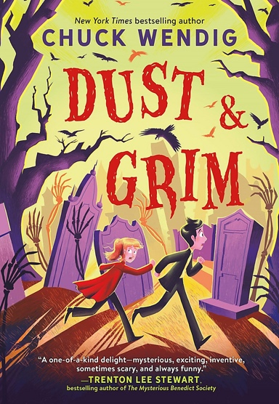 | 14.99 | 9780316706261
Lockwood & Co  By Jonathan Stroud  5 in the series | When the dead come back to haunt the living, Lockwood & Co. step in . . .  For more than fifty years, the country has been affected by a horrifying epidemic of ghosts. A number of Psychic Investigations Agencies have sprung up to destroy the dangerous apparitions.  Lucy Carlyle, a talented young agent, arrives in London hoping for a notable career. Instead, she finds herself joining the smallest most ramshackle agency in the city, run by the charismatic Anthony Lockwood. When one of their cases goes horribly wrong, Lockwood & Co. have one last chance of redemption. Unfortunately, this involves spending the night in one of the most haunted houses in England, and trying to escape alive.  Set in a city stalked by spectres, The Screaming Staircase is the first in a chilling new series full of suspense, humour and truly terrifying ghosts. Your nights will never be the same again . . . | 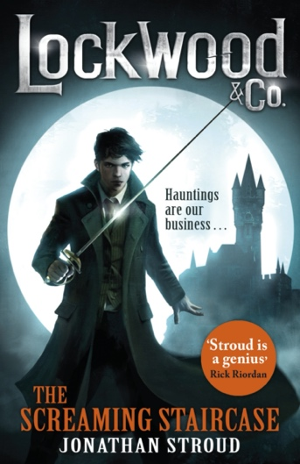 | 18.99 | 9780552566780
The Silver Eyes  By Scott Clayton  First of 5 | The first-ever graphic novel for Five Nights at Freddy’s. Complete with new information and tense, terrifying illustrations, fans won’t want to miss this graphic novel adaptation by Scott Cawthon, Kira Breed-Wrisley and Claudia Schroder, whose stunning artwork has been featured in the games. | 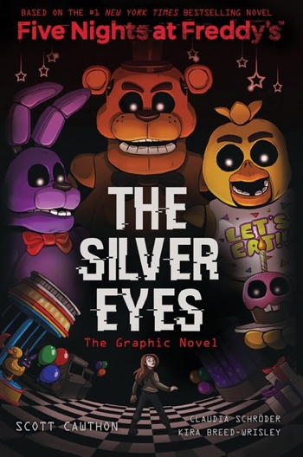 | 18.99 | 9781338298482
Dead Wednesday  By Jerry Spinelli | On Dead Wednesday, every eighth grader in Amber Springs is assigned the name and identity of a teenager who died a preventable death in the past year. The kids don black shirts and for the whole day everyone in town pretends they’re invisible-as if they weren’t even there. The adults think it will make them contemplate their mortality. The kids know it’s a free pass to get away with anything.  Worm Tarnauer feels invisible every day. He’s perfectly happy being the unnoticed sidekick of his friend Eddie. So he’s not expecting Dead Wednesday to feel that different. But he didn’t count on being assigned Becca Finch (17, car crash). And he certainly didn’t count on Becca showing up to boss him around! Letting this girl into his head is about to change everything.  This is the story of the unexpected, heartbreaking, hilarious, truly epic day when Worm Tarnauer discovers his own life. | 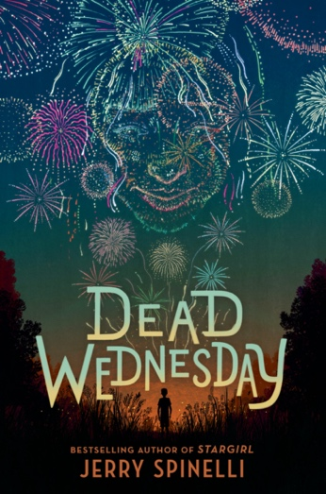 | 15.99 | 9780593425848
YA
She Is A Haunting  By Trang Thanh Tran | Jade Nguyen has always lied to fit in. She’s straight enough, Vietnamese enough, American enough at least for this summer with her estranged father in Vietnam. Just five weeks of ignoring the quietly decaying French colonial house he’s fixing up, then college and freedom are hers.  But soon Jade begins waking up every morning certain that something has clawed down her throat. . . from the inside. Then the ghost of a beautiful bride visits her with a cryptic warning- DON’T EAT.  When her father and little sister don’t believe her, Jade decides to scare them into leaving by staging some haunting events of her own. She recruits Florence, the daughter of her dad’s business associate (and more of a distraction than Jade bargained for) to help.  But the house has other plans. It’s hungry. A home, after all, is only as powerful as those who breathe new life into its bones. And this one is determined never to be abandoned again –  This deliciously spooky, yearningly romantic ghost story from a brilliant debut author will thrill fans of Kalynn Bayron and Wilder Girls by Rory Power. | 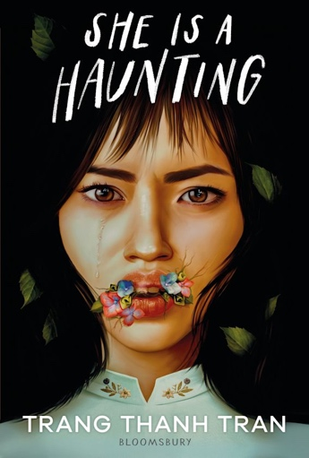 | 17.99 | 9781526657084
Night Lights  By Sarah Epstein  (AUS) | A remote cabin. A family on edge. They are not alone.  It was meant to be a family bonding exercise: two weeks in a mountain cabin on the outskirts of a former gold-mining town. These days, Wooralla’s only claim to fame is a retro diner called The Flying Saucer and a dusty museum dedicated to the area’s history of UFO sightings. Sixteen-year-old Owen knows it’s all bogus, but at least it gives him something to do.  Half a day into their holiday, Owen’s family is already bickering. By day two, his little sister is sick. On the third night, they witness peculiar lights in the sky.  By day nine they are fleeing, too panicked to grab their phones, belongings, even the family dog. Owen doesn’t know what they’re running from, he only knows he needs to keep his little sister safe. But how can he tell anyone about his dad’s erratic behaviour? Weird howling from deep in the bush? Strange entities hiding in the trees? How does he explain what was real and what wasn’t when he doesn’t even know himself?  In Owen’s search for answers, nothing is as it seems. And what he’ll uncover is beyond anything he imagined. | 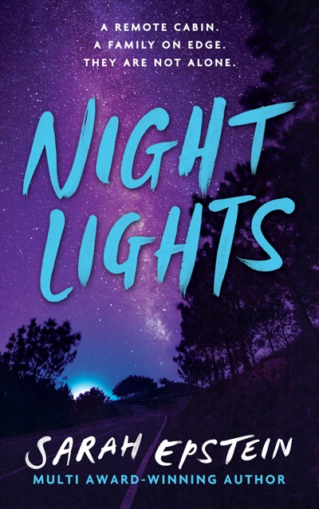 | 24.95 | 9780645332292
House Of Hollow  By Krystal Sutherland | Iris Hollow and her two older sisters are unquestionably strange. Ever since they disappeared on a suburban street in Scotland as children only to return a month a later with no memory of what happened to them, odd, eerie occurrences seem to follow in their wake. And they're changing. First, their dark hair turned white. Then, their blue eyes slowly turned black. People find them disturbingly intoxicating, unbearably beautiful and inexplicably dangerous.  Now, ten years later, seventeen-year-old Iris Hollow is doing all she can to fit in and graduate high school - something her two famously glamorous globe-trotting older sisters, Grey and Vivi, never managed to do. But when Grey goes missing, leaving behind only bizarre clues, Iris and Vivi are left to trace her last few days. They aren't the only ones looking for her. As they brush against the supernatural, they realise that the story they've been told about their past is unravelling and the world that returned them seemingly unharmed ten years ago, might just be calling them home. | 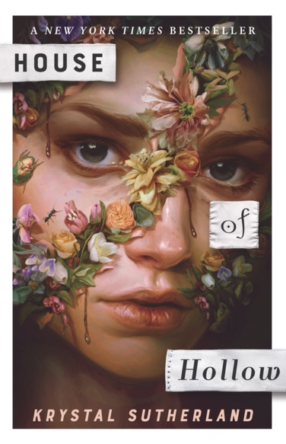 | 19.99 | 9780143796992
What We All Saw  By Mike Lucas  (AUS) | Witches only exist in stories. Everyone knows that. But what if the stories are real?  FOUR FRIENDS. FOUR TRUTHS. ONE NIGHTMARE.  If you wander into the wood ...  If you hear scratching sounds from the Old Quarry ...  If you go too close to the edge ...  WATCH. OUT. | 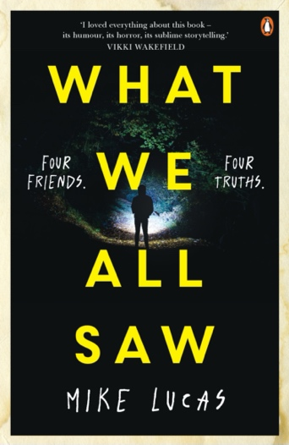 | 19.99 | 9781761045936
The Taking of Jake Livingston | Sixteen-year-old Jake Livingston sees dead people everywhere. But he can’t decide what’s worse: being a medium forced to watch the dead play out their last moments on a loop or being at the mercy of racist teachers as one of the few Black students at St Clair Prep. Both are a living nightmare he wishes he could wake up from. But things at St Clair start looking up with the arrival of another Black student – the handsome Allister – and for the first time, romance is on the horizon for Jake.  Unfortunately, life as a medium is getting worse. Though most ghosts are harmless, Sawyer Doon wants much more from Jake. In life, Sawyer was a troubled teen who shot and killed six kids at a local high school before taking his own life. Now he’s a powerful, vengeful ghost and he has plans for Jake. High school has become a different kind of survival game – one Jake is not sure he can win. | 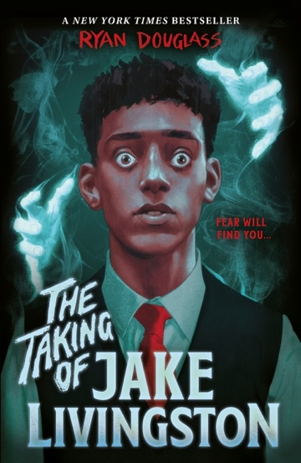 | 18.99 | 9781839132506
Together We Rot  By Skyla Arndt | Wil Greene’s mom has been missing for over a year, and the police are ready to call the case closed—they claim she skipped town and you can’t find a woman who wants to disappear. But she knows her mom wouldn’t just leave…and she knows the family of her former best friend, Elwood Clarke, has something to do with it.  Elwood has been counting down the days until his 18th birthday—in dread. It marks leaving school and joining his pastor father in dedicating his life to their congregation, the Garden of Adam. But when he comes home after one night of after a final goodbye with his friends, already self-flagellating for the sins of drinking and disobeying his father, he discovers his path is not as virtuous as he thought. He’s not his father’s successor, but his sacrifice. For the woods he’s grown up with are thirsty, and must be paid in blood.  Now on the run from a family that wants him dead, he turns to the only one who will believe him: Wil. Together, they form a reluctant partnership; she’ll help him hide if he helps her find evidence that his family killed her mother. But in the end they dig up more secrets than they bargained for, unraveling decades of dark cult dealings in their town, led by the Clarke family.  And there’s a reason they need Elwood’s blood for their satanic rituals. Something inhuman is growing inside of him. Everywhere he goes, the plants come alive and the forest calls to him, and Wil isn’t sure if she can save the boy she can’t help but love. | 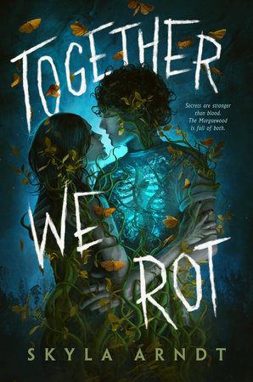 | 18.99 | 9780593526279  Aug 2023
Where Echoes Die  By Courtney Gould | In Where Echoes Die, Courtney Gould draws readers into a haunting desert town to explore grief, the weight of not letting go of the past, first love, and the bonds between sisters, mothers and daughters. | 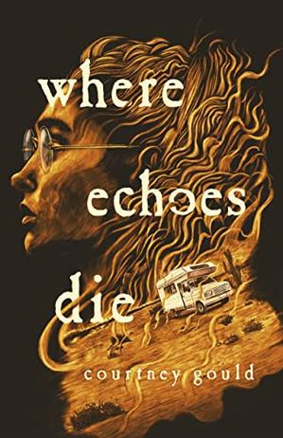 |  | 9781250825797  Later this year
Where Darkness Blooms  By Andrea Hannah | Andrea Hannah’s Where Darkness Blooms is a supernatural thriller about an eerie town where the sunflowers whisper secrets and the land hungers for blood. The town of Bishop is known for exactly two things: recurring windstorms and an endless field of sunflowers that stretches farther than the eye can see. And women—missing women. So when three more women disappear one stormy night, no one in Bishop is surprised. The case is closed and their daughters are left in their dusty shared house with the shattered pieces of their lives. Until the wind kicks up a terrible secret at their mothers’ much-delayed memorial. With secrets come the lies each of the girls is forced to confront. After caring for the other girls, Delilah would like to move on with her boyfriend, Bennett, but she can’t bear his touch. Whitney has already lost both her mother and her girlfriend, Eleanor, and now her only solace is an old weathervane that seems to whisper to her. Jude, Whitney’s twin sister, would rather ignore it all, but the wind kicks up her secret too: the summer fling she had with Delilah’s boyfriend. And more than anything, Bo wants answers and she wants them now. Something happened to their mothers and the townsfolk know what it was. She’s sure of it. Bishop has always been a strange town. But what the girls don’t know is that Bishop was founded on blood—and now it craves theirs. | 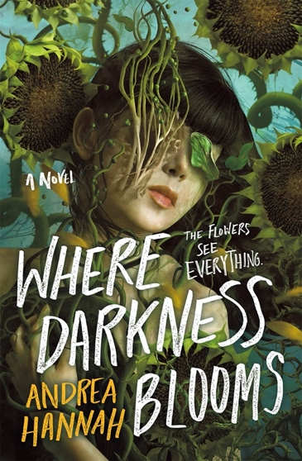 | 26.99 | 9781250290168  Feb 23
Lying In The Deep  By Diana Urban | After being jilted by her ex-boyfriend and best friend, Jade couldn’t be more ready to embark on the adventure of a lifetime-11 countries in 4 months, all from the luxurious Campus on Board ship-and to wedge an entire globe between her and the people who broke her heart.  But when Jade discovers the backstabbing couple are also setting sail, her obsession with them grows and festers, leading to a shocking murder. And as their friends begin to drop like flies, Jade and her new crush must race to clear her name and find the killer they’re trapped at sea with….before anyone else winds up in body bags. | 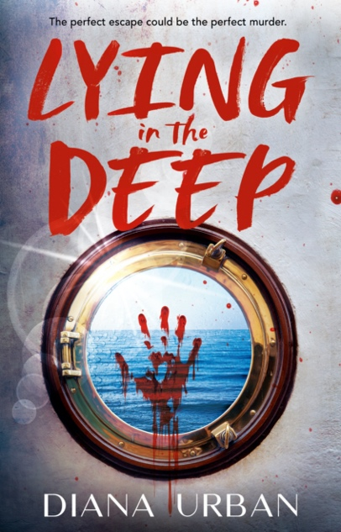 | 19.99 | 9780593696040  Aug ‘23
The Cherished  By Patricia Ward | an original, hypnotizing horror thriller in the vein of Midsommar, as one girl inherits a mysterious house from her estranged grandmother—and a letter with sinister instructions.  Jo never expected to be placed in her absent grandmother’s will—let alone be left her house, her land, and a letter with mysterious demands.  Upon arriving at the inherited property, things are even more strange.  The tenants mentioned in the letter are odd, just slightly…off. Jo feels something dark and decrepit in the old shack behind the house. And the things that her father used to talk about, his delusions… Why is Jo starting to believe they might be real  But what Jo fears most is the letter from her grandmother. Because if it’s true, then Jo belongs here, in this strange place. And she has no choice but to stay. | 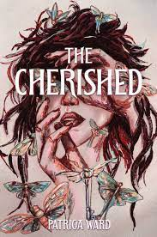 | 29.99 | 9780063235113  Due Aug ‘23
The Spider and her Demons  By Sydney Khoo | Uncover an extraordinary world of demons and witches, where the ones you love can hurt you the most and hiding your true self can get you killed.  Moving and funny by turns, this is a story about what it takes to make peace with your demons - literal or otherwise. An urban fantasy spin on growing up as a second-generation immigrant, struggling under the overwhelming pressure to make others proud, while feeling trapped inside your own body.  Between surviving high school and working at her aunt's dumpling shop, all Zhi wants is to find time for her friends . . . and make sure no one finds out she's half spider-demon.  But when she accidentally kills and eats a man in front of the most popular girl in school, she discovers she might not be the scariest thing in the shadows. | 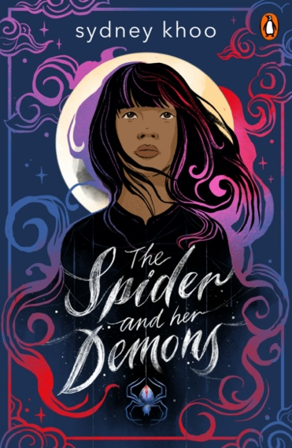 | 19.99 | 9781761047572  Due Aug

Jenny Kiely
schools@sunbookshop.com

