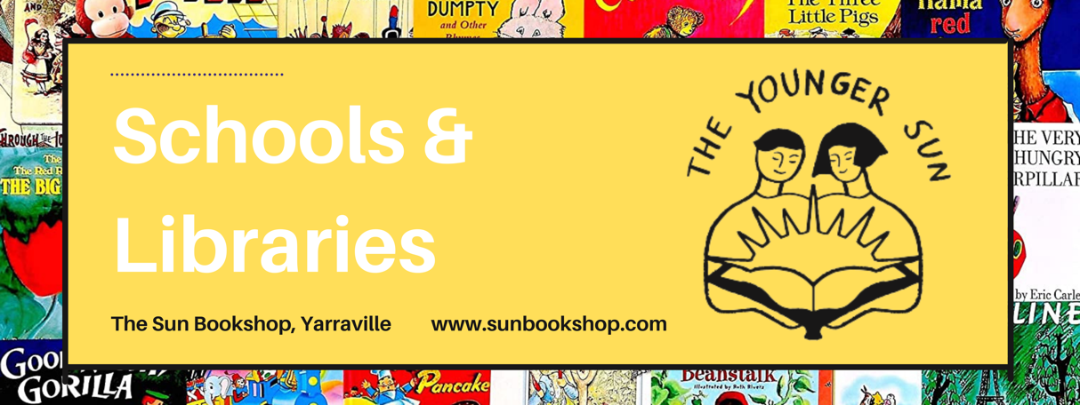

SLAV
Thursday June 15th

TOPIC: Novels to Enhance Curriculum Areas

Cross-curriculum Priorities

Learning about Aboriginal and Torres Strait Islander histories and cultures

JUNIOR | SENIOR
Our Race For Reconciliation – Anita Heiss | Boy From The Mish – Gary Lonesborough
Who Am I? (My Australian Story) – Anita Heiss | We Didn’t Think It Through – Gary Lonesborough
Maybe Tomorrow – Boori Monty Prior | The Upwelling – Lystra Rose
Sea Horse - Bruce Pascoe | My Spare Heart – Jared Thomas
The Dog Runner – Bren McDibble | Ghost Bird - Lisa Fuller
Njunjul the Sun – Meme McDonald | The Tribe Series – Ambelin Kwaymullina
My Girragundji – Meme McDonald | Sister Heart – Sally Morgan
The Binna Binna Man – Meme McDonald | Catching Teller Crow – Ambelin Kwaymullina
Wylah: The Koorie Warrior series – Jordan Gould | My Place (Young Readers – Sally Morgan
Koori Princess – Anita Heiss | Jandamarra and the Bunuba Resistance – Banjo Woorunmurra
Maku – Meyne Wyatt | Calypso Summer – Jared Thomas
Ngiya Yintanga Japarrika – Tiwi College | Songs That Sound Like Blood – Jared Thomas
Japarrika Rises – Tiwi College | Tracks of the Missing – Carl Merrison
Uncle X-Box – Jared Thomas | My Father’s Shadow – Jannali Jones
The Secret of the Black Bushranger – Jackie French | Mrs Whitlam – Bruce Pascoe
Birrung the Secret Friend – Jackie French | Becoming Kirrali Lewis – Jane Harrison
Nanberry Black Brother White – Jackie French | Deadly Unna? – Phillip Gwynne
Saltwater Boy – Bradley Christmas | White Girl – Tony Birch
Ubbies Underdogs series (Graphic Novels) | Follow the Rabbit Proof Fence – Doris Pilkington
 | BURN – Melanie Saward (Due August)

Learning about Asia and Australia’s engagement with Asia

JUNIOR | SENIOR
Fly On the Wall – Remy Lai | Tiger Daughter – Rebecca Lim
The Glow – Sophie Laguna | Laurinda – Alice Pung
All Four Quarters of the Moon – Shirley Marr | A Magic Steeped In Poison – Judy Lin
A Glasshouse of Stars – Shirley Marr | The Girl Who Fell Beneath the Sea – Axie Oh
Our Australian Girl : Marley – Alice Pung | A Taste of Love – Jennifer Yen
Dragonkeeper Series – Carole Wilkinson | The Henna Wars – Adiba Jaigirdar
The Garden of Empress Cassia – Gabrielle Wang | Hani & Ishu’s Guide to Fake Dating - Adiba Jaigirdar
The Pearl of Tiger Bay – Gabrielle Wang | Tokyo Ever After – Emiko Jean
Zadie Marr & the Dog Who Chased the Moon | The Magic Fish – Trung Le Nguyen
Plum &Woo series – Lisa Siberry | Six Crimson Cranes – Elizabeth Lin
What About Thao – Oliver Phommavanh | To All the Boys I’ve Loved (series) Jenny Han
When Clouds Touch Us – Thanhha Lai | Iron Widow – Xiran Jay Zhao
Inside Out and Back Again – Thanhha Lai | Strike the Zither – Joan He
The Lost Ryu – Emi Watanabe Cohen | This Time It’s Real – Ann Liang
Kiki’s Delivery Service – Eiko Kadono | Only A Monster – Vanessa Len
Zachary Ying and the Dragon Emporer – Xiran Jay Zhao | Catfish Rolling – Clara Kumagai
American Born Chinese – Gene Luen Yang | The Ones We’re Meant To Find – Joan He

Learning about Sustainability

JUNIOR | SENIOR
The Callers – Kiah Thomas | Green Rising – Lauren James
The Last Wild – Piers Torday | What Now, Tilda B? - Kathryn Lomer
The Dark Wild – Piers Torday | As Stars Fall - Christie Nieman
The Wild Before – Piers Torday | Into That Forest – Lois Nowra
The Wild Beyond – Piers Torday | Two Degrees - Alan Gratz
Wind Riders (series) – Jen Marlin | Tyenna - Through My Eyes - Australian Disaster Zones – Julie Hunt
Polar Bear Patrol – Jess Butterworth | If Not Us – Mark Smith
The Adventure Club – Jess Butterworth
The Orphan Orangutan – Jess Butterworth
Polly Pecorino – Emma Chichester Clark
The Wild Robot – Peter Brown
The One & Only Ruby – Katherine Applegate | The Sky So Heavy – Claire Zorn
The Letterbox Tree – Rebecca Lim/Kate Gordon | When We Are Invisible – Claire Zorn
Dear Greta – Yvette Poshoglian
The Orchard Underground – Mat Larkin
Devils In Danger – Samantha Wheeler
The Good Times of Pelican Rise – Samone Amba
The Last Bear – Hannah Gold
The Lost Whale – Hannah Gold

