SLAV – FANTASY UPCOMING
YOUNG ADULT
DARK RISE 2: Dark Heir – 14 November 2023  In this riveting sequel to the New York Times bestselling novel Dark Rise, Will and his allies have survived the Dark's first assault, but at a terrible cost.  Description  The Dark King has risen. The Hall of the Stewards is in ruins. Only a handful of heroes remain to fight.  Pursued by dark forces, Will and his allies must travel to the heart of the ancient world, forging new and dangerous ties, and revealing the shocking secrets of the past.  But Will is carrying a dark secret of his own - his true identity. Drawn to the beautiful and deadly James St. Clair, Will is pulled ever deeper into the web of the past, tempted by the darkness within. As the ancient world threatens to return, can Will and his friends fight their fate? Or will the truths they learn tear their world apart? | 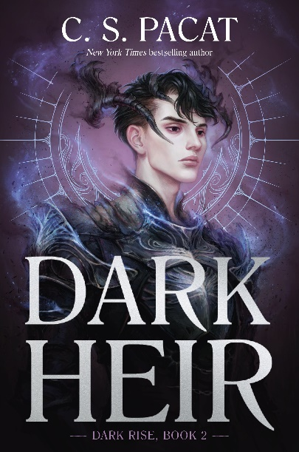
31 October 2023

Kaldoras
The Medoran Chronicles Epilogue
Lynette Noni
Journey back to the world of Medora to follow Alexandra Jennings and her friends – and enemies – for one last adventure.

Spanning four years after the final book in Lynette Noni’s #1 bestselling series The Medoran Chronicles, this is an epilogue like no other, full of laughter, tears, and above all, the unending power of friendship.

LIGHTLARK – 28 September 2023  Welcome to the Centennial.  Every hundred years, the island of Lightlark appears for only 100 days to host a deadly game, where the rulers of six realms fight to break their curses and win unparalleled power. Each ruler has something to hide. Each curse is uniquely wicked. To break them-and save themselves and their realms-one ruler must die.  To survive, Isla Crown must lie, cheat, and betray. Even as love complicates everything . . .  This paperback edition will include a teaser chapter of the upcoming second book in the Lightlark Saga. | 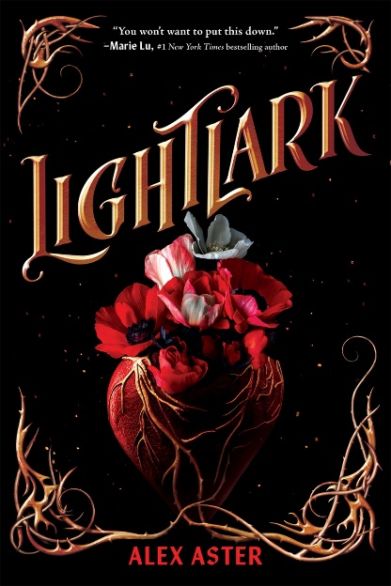
SIR HEREWARD AND MISTER FITZ – 22 September 23  New York Times bestselling author Garth Nix's collection of all eight stories - plus a never-before-published story - featuring Sir Hereward and his mysterious companion Mister Fitz, gathered in one magical volume for the first time ever!  Description  Sir Hereward: the only male child of an ancient society of witches. Knight, artillerist, swordsman. Mercenary for hire. Ill-starred lover.  Mister Fitz: sorcerous puppet, lore master. Practitioner of arcane arts and wielder of sorcerous needles.  Sir Hereward and Mister Fitz: god slayers. Agents of the Council of the Treaty for the Safety of the World, charged with the location and removal of listed extra-dimensional entities, more commonly known as gods.  Together, they are relentless travellers in a treacherous world of magic, gunpowder, and adventure.  From the award-winning author and bestselling creator of the Old Kingdom series and The Left-handed Booksellers of London comes this must-have fantasy collection for fans and those about to discover the witch knight and his puppet sorcerer for the first time. | 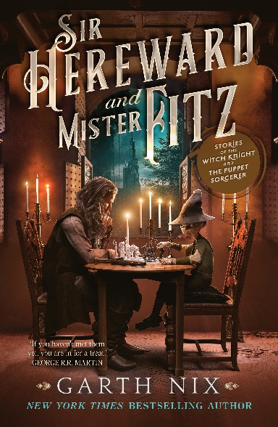
WE WHO ARE FORGED IN FIRE – 30 August 2023  Sequel – We Who Hunt the Hollow  An electrifying urban fantasy about a family of women warriors, and a girl who will risk everything to save them …  Priscilla Daalman is training to be a Hollow Warrior – an elite monster hunter charged with killing evil beasts from another universe. But first, she has to deal with the Renegades, a rebellious group of outcasts who have declared war on the warriors and are unleashing deadly beasts across the globe.  With everyone under attack by both Renegades and Hollow monsters, Priscilla decides the best way to fight is from within – so she cuts herself off from her girlfriend and family and becomes a spy in the Renegades’ base. It’s a bold plan – and one that doesn’t account for her duplicitous ex-boyfriend, Dominic, being a leader of the rebellious group.  As Priscilla struggles to remain undetected in the Renegade base, she realises Dominic has his own agenda – and she’s part of it. And in order to stop him – and the Renegades – she may have to make the ultimate sacrifice …  Full of breathtaking twists and turns, We Who Are Forged in Fire is the thrilling sequel to We Who Hunt the Hollow, Kate Murray’s debut YA novel that won the Victorian Premier's Literary Award for Young Adults and was shortlisted for the Ampersand Prize and the Readings Prize. | 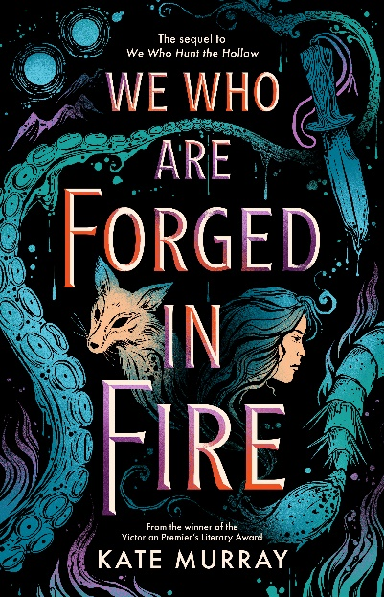
ARCHIVES OF DISPAIR – 19/09/23  From the chilling mind of Caleb Finn comes his debut Young Adult book- a collection of ten stories to haunt your thoughts and fuel your darkest fears.  You have been given access to secret files buried deep within the archives. Disturbing stories never meant for the light of day.  Stories of evil grandparents and unsettling homework.  A string of deaths, seemingly unrelated.  Walls squirm, as if alive.  A cursed wish comes true.  Ordinary people behave oddly, even family and your closest friends . . .  These stories share a common fate. All the children are met with tragedy.  Coincidence?  Or could these nightmares be connected by something more sinister than you dare to imagine?  From TikTok superstar Caleb Finn, a horrific masterpiece for readers aged 15+. | 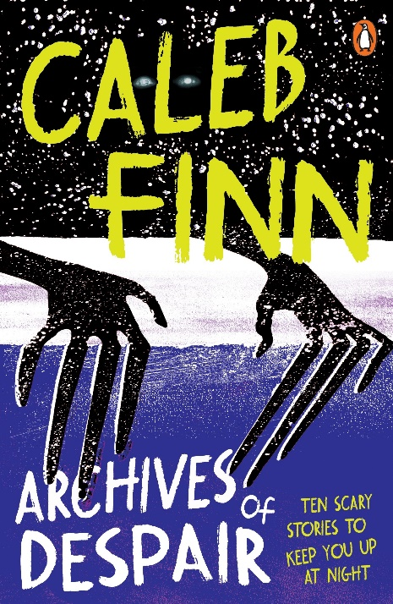
MIDDLE GRADE
Crookhaven Book 2: The Forgotten Maze – 29 August 2023  An irresistible series about chosen family, high stakes thievery, and what it really means to do good. Perfect for fans of M.G. Leonard and Anthony Horowitz.  It's Gabriel's second year at Crookhaven School for Thieves. And with a tricky Break-In challenge to the teacher's section of the library to attempt, plus a new class called Reclamation, his Miscreant year is already off to a busy start.  Then Gabriel and his friends learn about Maravel's Maze. Hidden deep beneath the lake, forgotten about by the school, it's a labyrinth of obstacles. Each tests a crook-related skill - and all are nearly impossible.  But the impossible has never stopped Gabriel's crew before, especially not when there's something at the heart of the maze that they all desperately want...  The second book in the 'criminally good' Crookhaven series, the secret school where students are taught to do wrong, so that one day, they can put the world to right. | 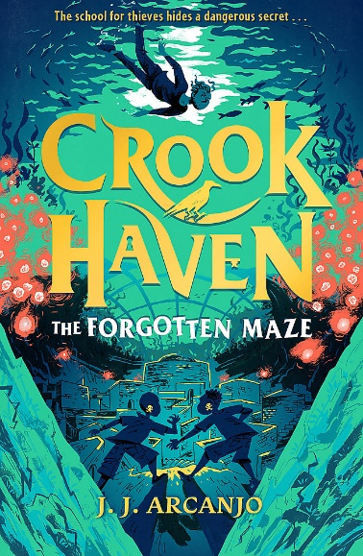
Mermedusa – 29 August 2023  An Eerie-on-Sea Mystery (Malamanda, Shadowghast etc)  Herbie and Violet's fifth gripping adventure brings the internationally bestselling Eerie-on-Sea series to a heart-stopping climax.  It is midwinter once again, and the hosts of a paranormal podcast have descended on Eerie-on-Sea eager for a sighting of the legendary malamander. Herbert Lemon, Lost-and-Founder at the Grand Nautilus Hotel, is feeling uneasy – and not just because of the visitors. He’s being plagued by unsettling dreams, and the head-splitting “Eerie Hum” that is reverberating through the town.  Something is dreadfully wrong, and it seems to be coming from Eerie's very core. Herbie and his friend Violet Parma will need all their courage as they head deep below the town to seek answers. Perhaps here, finally, they – and the malamander too – will discover the Deepest Secret of Eerie-on-Sea. | 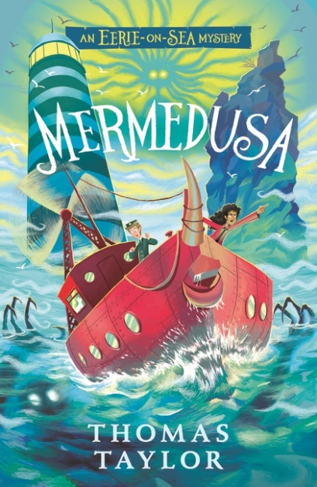
The Chalice of the Gods - 9 November 2023  The original heroes from The Lightning Thief are reunited for their biggest challenge yet- getting Percy to college when the gods are standing in his way.  Percy Jackson has saved the world multiple times - battling monsters, Titans, even giants - but these days the modern-day son of Poseidon is hoping for a regular final year at school.  Too bad the Greek gods have other plans, and three new quests for Percy to complete.  First up- the cupbearer of the gods, Ganymede, is missing his golden chalice. Not only is this embarrassing (why do the gods keep losing their magical items?), it's also potentially disastrous. One sip from the cup will turn any mortal into a powerful god. And the old gods do not take kindly to newbies.  Can Percy and his friends Annabeth and Grover find the chalice before it falls into the wrong hands? And even if they do, will they be able to resist its awesome power. . .? | 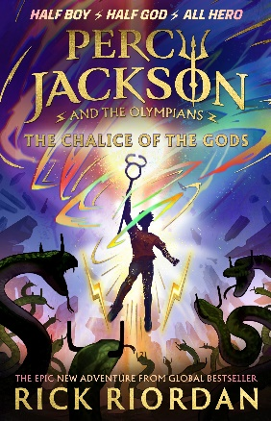
Murtagh – 7 November 2023  An epic new fantasy from the internationally bestselling author of ERAGON  Master storyteller and internationally bestselling author Christopher Paolini returns to the World of Eragon in this stunning epic fantasy set a year after the events of the Inheritance Cycle.  The world is no longer safe for the Dragon Rider Murtagh and his dragon, Thorn. An evil king has been toppled, and they are left to face the consequences of the reluctant role they played in his reign of terror.  Now they are hated and alone, exiled to the outskirts of society. Throughout the land, hushed voices whisper of brittle ground and a faint scent of brimstone in the air - and Murtagh senses that something wicked lurks in the shadows of Alagaësia. So begins an epic journey into lands both familiar and untravelled, where Murtagh and Thorn must use every weapon in their arsenal, from brains to brawn, to find and outwit a mysterious witch. A witch who is much more than she seems.  In this gripping novel starring one of the most popular characters from Christopher Paolini's blockbuster Inheritance Cycle, a Dragon Rider must discover what he stands for in a world that has abandoned him. | 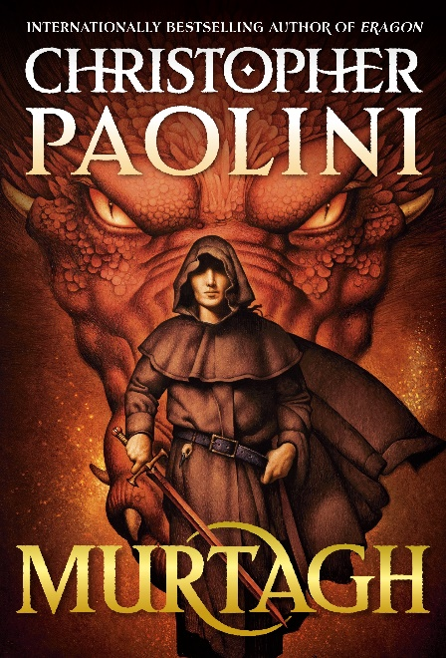
City of Dragons: Rise of the Shadowfire – 1 October 2023  A Graphic Novel (City of Dragons #2)  Ever since the battle in Hong Kong, Grace and her friends have been trying to find a way to get to Paris. When Nate suddenly appears and whisks Grace away to the Dragon King's lair, she learns that Daijiang and his underlings are searching for an ancient relic that will let them subjugate the dragons and Grace needs to find it first! With Grace's burgeoning Hunxue powers, the team must get to Paris and stop Daijiang's plan. But their new ally, Dr. Kim, may not be all she appears and Daijiang has formidable allies of his own: a strangely familiar accomplice and a terrifying, powerful dragon that could threaten all of Paris. | 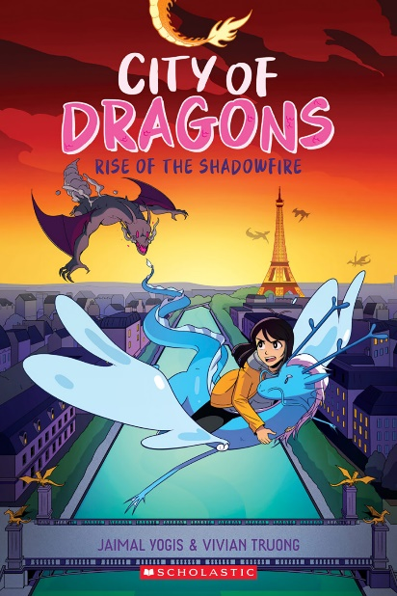
Which Way Round the Galaxy – 26 September 2023  Sequel to Which Way to Anywhere  The O'Hero-Smiths may have rescued their little sister Annipeck, found K2 and Izza's father Everest and triumphed over the robot assassin called the EXCORIATOR - but their story isn't quite over yet. Because there is danger and possibility in the Which Ways. And a new adventure bursting with magic is about to take them through the crossing points and into new worlds. | 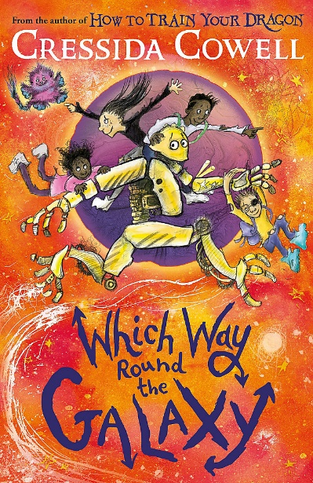
The lonely lighthouse of Elston-fright – 3 October 2023  Danger, darkness and a mysterious legacy unveiled in this magical seaside adventure by the bestselling author of A Girl Called Corpse.  Description  Being a Lightkeeper is Very Serious Business.  Nobody in Elston-Fright believes in magic anymore. Well, nobody except for Flip Little, his nan and his friends: a girl called Corpse, a ghost called Girl and a very large spider called Simon.  But when Simon is spider-napped by ancient weather ghouls called the Poltergusts, Flip and his ghostly companions turn to the last Lightkeeper's journals for answers. To rescue their friend, they will need to find and return the missing Light to the lighthouse, restoring its lost magic.  Only nothing in Elston-Fright is as it seems. Questions bubble up from the deep. Dark secrets come to light. And pretty soon, Flip and his friends learn that in order to save the future of Elston-Fright, they'll first need to understand its past. | 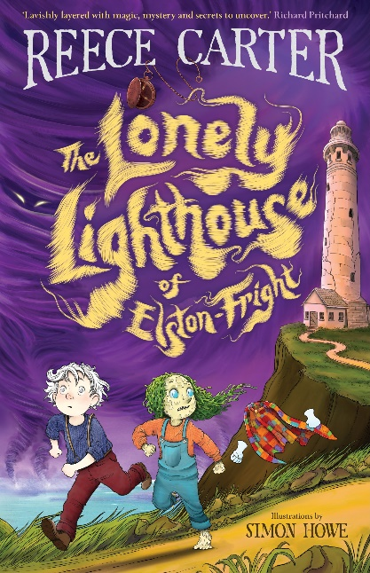
The Wild Robot Protects – 26 September 2023  The enchanting new addition to the #1 New York Times bestselling THE WILD ROBOT series from award-winning author-illustrator Peter Brown, packed full of glorious illustrations.  Roz the robot has made an unlikely home for herself on an idyllic island dense with forests, wildflowers and friendly animal inhabitants - including her own young son Brightbill the gosling. Life on the island is perfect, until a dying seal washes ashore and warns of dangerous, cloudy waters that are flowing toward the island, bringing new dangers for the animals.  Forced inland they will have to fight over fewer resources - and Roz realizes that she must march into the waves and undertake an incredible undersea adventure to find a way to protect her beloved island and all who live on it ... | 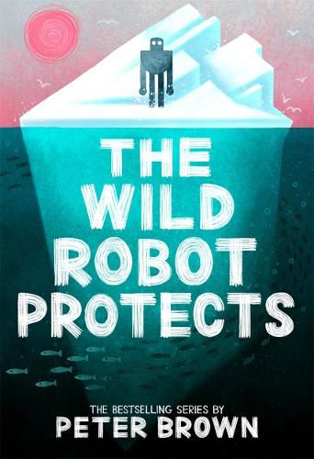
Deadlands Trapped – 3 October 2023  Dinosaurs fight for freedom and survival in book two of this action-packed middle-grade series.  Battle rages on between the two surviving dinosaur kingdoms.  Eleri and his fellow outcasts are searching for evidence to prove that the carnivores have manipulated the herbivore kingdoms into war, so they can feast on the slain. But soon the friends must flee from a pack of raptors and become trapped inside the Fire Peak: the volcanic heart of the dreaded Carrion Kingdom. Can the outcasts escape and gather proof of the Carrion Kingdom’s vicious plans in one fell swoop? | 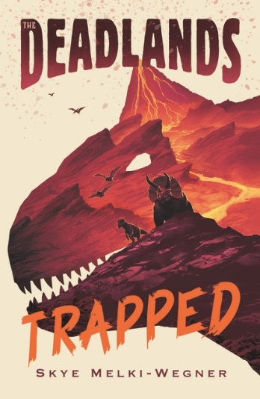
ADULT
30 January 2024 (Officially Adult)  The stunning third book in the sexy, action-packed Crescent City series, following the  global bestsellers House of Earth and Blood and House of Sky and Breath.  Bryce Quinlan never expected to see a world other than Midgard, but now that she has, all she wants is to get back. Everything she loves is in Midgard- her family, her friends, her mate. Stranded in a strange new world, she's going to need all her wits about her to get home again. And that's no easy feat when she has no idea who to trust.  Hunt Athalar has found himself in some deep holes in his life, but this one might be the deepest of all. After a few brief months with everything he ever wanted, he's in the Asteri's dungeons again, stripped of his freedom and without a clue as to Bryce's fate. He's desperate to help her, but until he can escape the Asteri's leash, his hands are quite literally tied.  In this sexy, breathtaking sequel to the #1 bestsellers House of Earth and Blood and House of Sky and Breath, Sarah J. Maas's Crescent City series reaches new heights as Bryce and Hunt's world is brought to the brink of collapse with its future resting on their shoulders. | 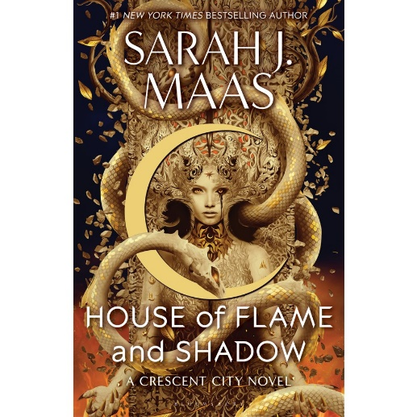
26 September 2023  The Fragile Threads of Power. Set in the Shades of Magic universe, this epic fantasy features familiar characters and setting, introducing a new generation of magic, shadows and adventure into the much-loved world.  'Once, there were four worlds, nestled like pages in a book, each pulsing with fantastical power, and connected by a single city: London, until the magic grew too fast, and forced the worlds to seal the doors between them in a desperate gamble to protect their own.  The few magicians who could still open the doors grew rarer as time passed and now, only three Antari are known in recent memory — Kell Maresh of Red London, Delilah Bard of Grey London, and Holland Vosijk, of White London.  But barely a glimpse of them have been seen in the last seven years — and a new Antari named Kosika has appeared in White London, taking the throne in Holland's absence,' it continues. 'The young queen is willing to feed her city with blood, including her own — but her growing religious fervor has the potential to drown them instead. And back in Red London, King Rhy Maresh is threatened by a rising rebellion, one determined to correct the balance of power by razing the throne entirely.  Amidst this tapestry of old friends and new enemies, a girl with an unusual magical ability comes into possession of a device that could change the fate of all four worlds,' the description concludes. 'Her name is Tes, and she's the only one who can bring them together — or unravel it all.' | 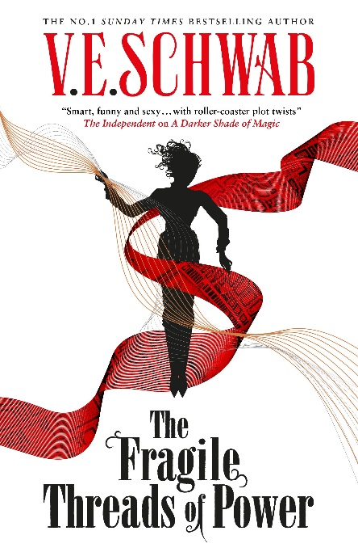
IRON FLAME – 8 November 2023  From the INSTANT SUNDAY TIMES BESTELLING author, Rebecca Yarros, comes the eagerly anticipated sequel to TIKTOK SENSATION Fourth Wing . . .  “The first year is when some of us lose our lives. The second year is when the rest of us lose our humanity.” —Xaden Riorson  Everyone expected Violet Sorrengail to die during her first year at Basgiath War College—Violet included. But Threshing was only the first impossible test meant to weed out the weak-willed, the unworthy, and the unlucky.  Now the real training begins, and Violet’s already wondering how she’ll get through. It’s not just that it’s grueling and maliciously brutal, or even that it’s designed to stretch the riders’ capacity for pain beyond endurance. It’s the new vice commandant, who’s made it his personal mission to teach Violet exactly how powerless she is–unless she betrays the man she loves.  Although Violet’s body might be weaker and frailer than everyone else’s, she still has her wits—and a will of iron. And leadership is forgetting the most important lesson Basgiath has taught her: Dragon riders make their own rules.  But a determination to survive won’t be enough this year.  Because Violet knows the real secret hidden for centuries at Basgiath War College—and nothing, not even dragon fire, may be enough to save them in the end. | 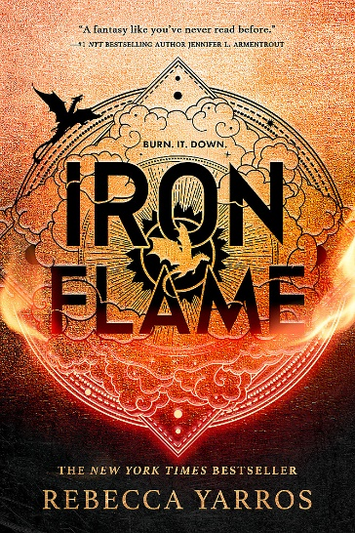
SWORD CATCHER – 10 October 23 (Author of The Mortal Instruments)  Two outcasts find themselves at the centre of world-altering change in the start of a riveting epic fantasy series from the No. 1 New York Times bestselling author of The Shadowhunter Chronicles.  In the vibrant city-state of Castellane, the richest of nobles and the most debauched of criminals have one thing in common: the constant search for wealth, power and the next hedonistic thrill. Kel is an orphan, stolen from the life he knew to become the Sword-Catcher – the body-double of a royal heir, Prince Conor Aurelian. He has been raised alongside the prince, trained in every aspect of combat and statecraft. He and Conor are close as brothers, but Kel knows he has one destiny: to die for Conor. No other future is possible. Lin Caster is one of the Ashkar, a small community who still possess magical abilities. By law, they must live behind walls in the city, but Lin, a physician, ventures out to tend to the sick and dying of Castellane. Despite her skills, she cannot heal her best friend Mariam without access to forbidden knowledge. After a failed assassination attempt brings Lin and Kel together, they are drawn into the web of the mysterious Ragpicker King, the criminal ruler of Castellane’s underworld. He offers them each what they want most; but as they descend into his world of intrigue and shadow, they discover a conspiracy of corruption that reaches from the darkest gutters of Castellane to the highest tower of its palaces. As long-kept secrets begin to unravel, they must ask themselves: is knowledge worth the price of betrayal? Can forbidden love bring down a kingdom? And will Lin and Kel’s discoveries plunge their nation into war – and the world into chaos? | 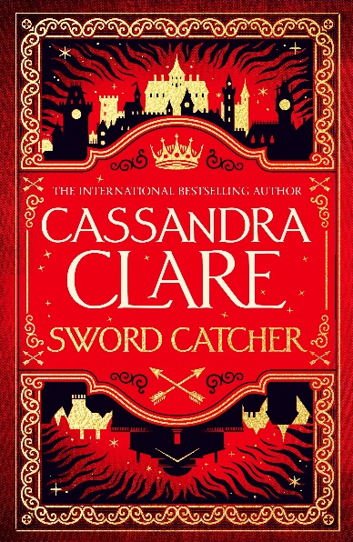
STAFF/CUSTOMER FAVOURITES YA
Whisper Series  Lynette Noni  For over two and half years, Subject Six-Eight-Four — ‘Jane Doe’ — has been locked away and experimented on in a secret government facility called Lengard. In that time, she hasn’t spoken a single word.  As Jane’s resolve begins to crack under the influence of her new and unexpectedly kind evaluator, she uncovers the truth about Lengard’s mysterious program, discovering that her own secret is at the heart of a sinister plot.  Desperate to save her friends — and the rest of the world — from the looming danger, Jane must first question everything she has ever believed, especially when long-lost memories begin to surface and the mysteries of her past continue to grow.  Allies become enemies and enemies become allies, leaving her certain about only one thing:  One wrong move, one wrong word, could change the world.  The Whisper Series is an epic duology of Young Adult dystopian fiction consisting of Whisper and Weapon. | 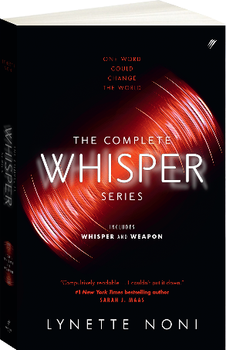
Song of the Lioness Quartet – FINALLY REPRINTING ! 26/09/23  MG  From now on, I’m Alan of Trebond, the younger twin. I’ll be a knight.  In a time when girls are forbidden to be warriors, Alanna of Trebond wants nothing more than to be a knight of the realm of Tortall. So she finds a way to switch places with her twin brother, Thom, and, disguised as a boy, begins her training as a page at the palace of King Roald. But the road to knighthood, as she discovers, is not an easy one. Alanna must master weapons, combat, and magic, as well as polite behavior, her temper, and even her own heart.  So begin Alanna’s adventures—filled with swords and sorcery, adventure and intrigue, good and evil—that will lead to the fulfillment of her dreams and make her a legend in the land. | 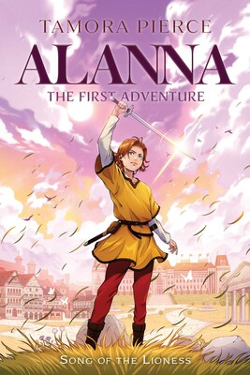
The Tribe Series
The Interrogation of Ashala Wolf – Ambelin Kwaymullina

Join the Rebellion!
“There will come a day when a thousand Illegals descend on your detention centres. Boomers will breach the walls. Skychangers will send lightning to strike you all down from above, and Rumblers will open the earth to swallow you up from below … And when that day comes, Justin Connor, think of me.”
Ashala Wolf has been captured by Chief Administrator Neville Rose. A man who is intent on destroying Ashala’s Tribe – the runaway Illegals hiding in the Firstwood. Injured and vulnerable and with her Sleepwalker ability blocked, Ashala is forced to succumb to the machine that will pull secrets from her mind. And right beside her is Justin Connor, her betrayer, watching her every move. Will the Tribe survive the interrogation of Ashala Wolf?
The Prison Healer – Lynette Noni  Here at Zalindov, the only person you can trust is yourself.  Seventeen-year-old Kiva Meridan has spent the last ten years fighting for survival in the notorious death prison, Zalindov, working as the prison healer.  When the Rebel Queen is captured, Kiva is charged with keeping the terminally ill woman alive long enough for her to undergo the Trial by Ordeal- a series of elemental challenges against the torments of air, fire, water and earth, assigned to only the most dangerous of criminals.  Then a coded message from Kiva’s family arrives, containing a single order- Don’t let her die. We are coming. Aware that the Trials will kill the sickly queen, Kiva risks her own life to volunteer in her place. If she succeeds, both she and the queen will be granted their freedom.  But no one has ever survived.  With an incurable plague sweeping Zalindov, a mysterious new inmate fighting for Kiva’s heart, and a prison rebellion brewing, Kiva can’t escape the terrible feeling that her trials have only just begun. | 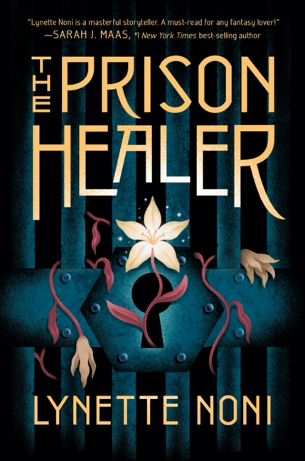
The Folk of the Air Series  The Cruel Prince  Of course I want to be like them. They're beautiful as blades forged in some divine fire. They will live forever . . . And Cardan is even more beautiful than the rest. I hate him more than all the others. I hate him so much that sometimes when I look at him, I can hardly breathe.  One terrible morning, Jude and her sisters see their parents murdered in front of them. The terrifying assassin abducts all three girls to the world of Faerie, where Jude is installed in the royal court but mocked and tormented by the Faerie royalty for being mortal. As Jude grows older, she realises that she will need to take part in the dangerous deceptions of the fey to ever truly belong. But the stairway to power is fraught with shadows and betrayal. And looming over all is the infuriating, arrogant and charismatic Prince Cardan . . . | 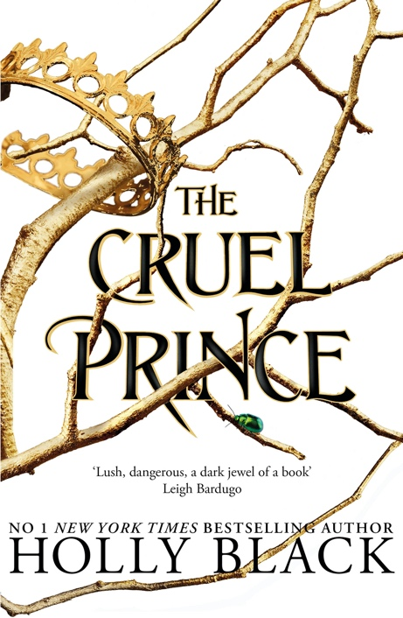
The Other Side of the Sky  Two worlds, two hearts and a choice that will shape their fate forever.  Prince North's home is in the sky, in a gleaming city held aloft by intricate unknown technology. But North believes his sky island is sinking. Its engines are failing, and the key to saving his home is to venture to the place the engines were first created.  Nimh is the living goddess of her people on the surface, responsible for providing answers, direction - hope. But in the midst of the surface's worst crisis yet, a mist that spreads madness and poison, doubts have arisen among the people about Nimh's divinity. She must find a way to manifest her power - before she is overthrown, and all is lost.  North's and Nimh's lives are entwined - though their hearts can never be. Linked by a terrifying prophecy and caught between duty and fate, they must choose to either save their people, or succumb to the bond that is forbidden to them. | 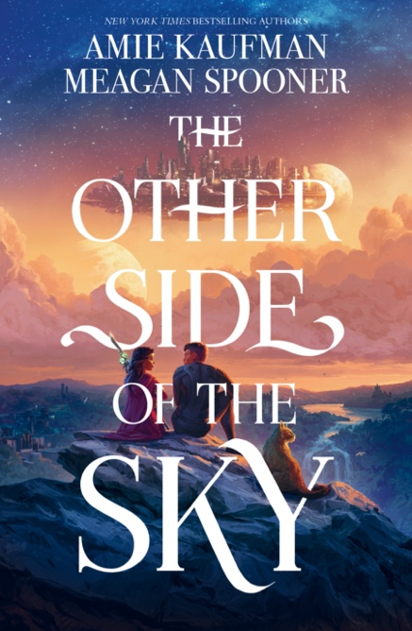
The Firemane Saga: King of Ashes  The first volume in legendary master and New York Times bestselling author Raymond E. Feist’s epic heroic fantasy series, The Firemane Saga – an electrifying tale of two young men whose choices will determine a world’s destiny.  The world of Garn once boasted five great kingdoms, until the King of Ithrace was defeated and every member of his family executed by Lodavico, the ruthless King of Sandura, a man with ambitions to rule the world.  Ithrace's ruling family were the legendary Firemanes, and represented a great danger to the other kings. Now four great kingdoms remain, on the brink of war. But rumour has it that the newborn son of the last king of Ithrace survived, carried off during battle and sequestered by the Quelli Nacosti, a secret society whose members are trained to infiltrate and spy upon the rich and powerful throughout Garn. Terrified that this may be true, and that the child will grow to maturity with bloody revenge in his heart, the four kings have placed a huge bounty on the child's head.  In the small village of Oncon, Declan is apprenticed to a master blacksmith, learning the secrets of producing the mythical king's steel. Oncon is situated in the Covenant, a neutral region lying between two warring kingdoms. Since the Covenant was declared, the region has existed in peace, until violence explodes as slavers descend upon the village to capture young men to press as soldiers for Sandura.  Declan must escape, to take his priceless knowledge to Baron Daylon Dumarch, ruler of Marquensas, perhaps the only man who can defeat Lodavico of Sandura, who has now allied himself with the fanatical Church of the One, which is marching across the continent, imposing its extreme form of religion upon the population and burning unbelievers as they go.  Meanwhile, on the island of Coaltachin, the secret domain of the Quelli Nacosti, three friends are being schooled in the deadly arts of espionage and assassination: Donte, son of one of the most powerful masters of the order; Hava, a serious girl with fighting abilities that can set any opponent on their back; and Hatu, a strange, conflicted lad in whom fury and calm war constantly, whose hair is a bright and fiery shade of red… | 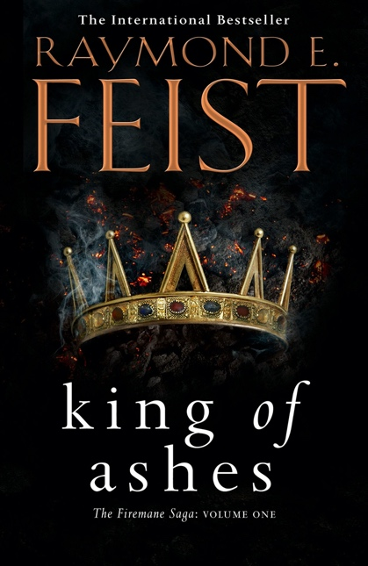
Serpent & Dove  Two years ago, Louise le Blanc fled her coven and took shelter in the city of Cesarine, forsaking all magic and living off whatever she could steal. There, witches like Lou are hunted. They are feared. And they are burned.  As a huntsman of the Church, Reid Diggory has lived his life by one principle: Thou shalt not suffer a witch to live. But when Lou pulls a wicked stunt, the two are forced into an impossible situation—marriage.  Lou, unable to ignore her growing feelings, yet powerless to change what she is, must make a choice. And love makes fools of us all.  Set in a world of powerful women, dark magic, and off-the-charts romance, book one of this stunning fantasy trilogy will leave readers burning for more. | 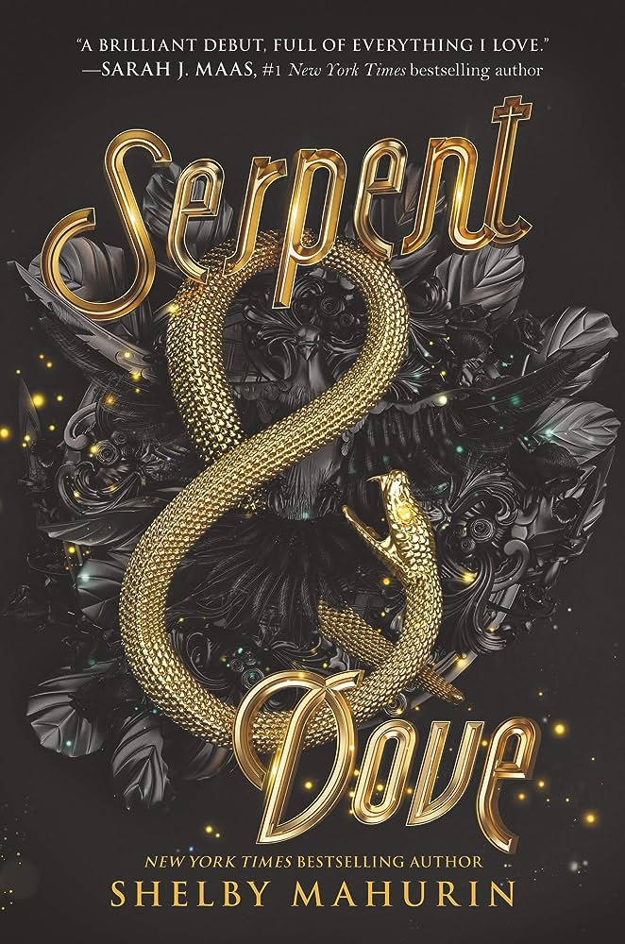
Gilded  A new fantastical retelling of Rumpelstiltskin, Gilded is the first instalment in a new duology from Marissa Meyer, the New York Times bestselling author of The Lunar Chronicles.  What if Rumpelstiltskin isn't the villain of the story?  By the following winter solstice, the miller would become the father of a baby girl. She was indeed healthy and strong, and in that, the god of stories had granted the wish precisely as requested. But what the miller had not considered is that the god of stories is also the god of lies. The trickster god. For every story has two sides to it. The hero and the villain. The dark and the light. The blessing and the curse.  Long ago, cursed by the god of lies, a poor miller's daughter has developed a talent for spinning stories that are fantastical and spellbinding and entirely untrue. Or so everyone believes. | 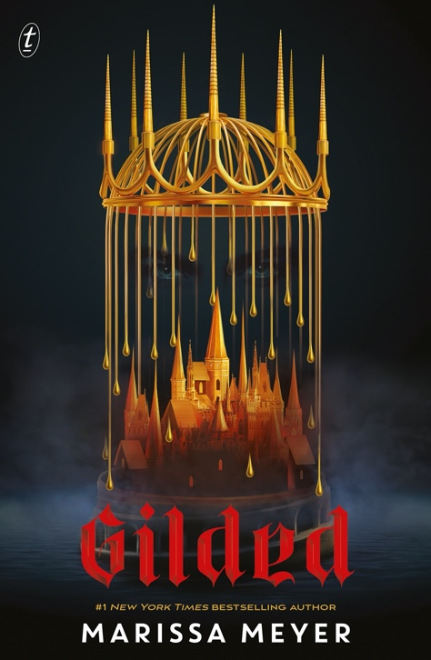
Nightbirds  Magic may be illegal in Simta, but you can find it if you know which whispers to heed. None as tantalising as the ones about the Nightbirds, Simta's best kept secret. These privileged girls have the ability to gift their magic to others with a kiss - something the church would have them killed for. But protected by the Great Houses, their identities safe behind masks, the Nightbirds are well-guarded treasures.  Matilde, AEsa, and Sayer spend their nights bestowing their unique brands of magic to well-paying clients. But this Season's Nightbirds find themselves at the heart of a political scheme that threatens their secrets and their safety. When they discover that their magic is far more than they were ever told, they see the carefully crafted Nightbird system for what it is: a gilded cage.  Now they must make a choice - to remain kept birds or take control, remaking the city that dared to clip their wings.  Filled with sumptuous, cinematic writing and dazzling details, Nightbirds is a fiercely feminist fantasy debut where the most potent magic lies not in a kiss, but in the truth. | 