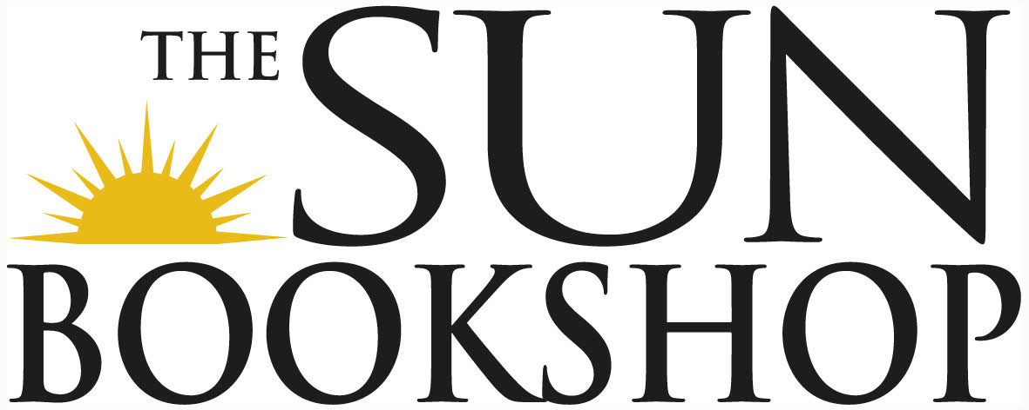
From Jenny at The Sun Bookshop

New adult 18- to 26-year-olds

“New Adult is an emerging market that brings readers in their late teens and early twenties, who are all too often missing from the pages of both Young Adult and Adult books, to the forefront” (Kieffer 1). In contrast with Young Adult (YA) which is aimed at teen readers (ages twelve to seventeen) with protagonists of the same age, New Adult (NA) targets emerging adult readers (ages eighteen to twenty-five). The fan website New Adult Alley states that, “‘New Adult characters are often portrayed experiencing college, living away from home for the first time, military deployment, apprenticeships, a first steady job and first serious relationship’” (Beckton 6). As with YA fiction, NA is a literary category containing all genres and sub-genres for every type of consumer (Beckton 7)

SOME NEW ADULT TITLES 2023
- Funny Ethnics, by Shirley Le (Aussie)
- Sad Girl Novel, by Pip Finkenmeyer (Aussie)
- Ripe, by Sarah Rose Etter (coming in Oct)
- Nothing Special, by Nicole Flattery
- Between You and Me, by Joanna Horton (new) (Aussie)
- Duck a l’Orange for Breakfast, by Karina May (Aussie)
- Without Further Ado, by Jessica Dettmann (Aussie)
- Happy Couple, by Naoise Dolan (new)
- The Rachel Incident, by Caroline O’Donoghue
- Shirley, by Ronnie Scott (Aussie)
- West Girls, by Laura Elizabeth Woollett (new this month) (Aussie)
- Mrs S, by K. Patrick
- Beatrix & Fred, by Emily Spurr (new) (Aussie)
- Others Were Emeralds, by Lang Leav (new) (Aussie)
- The Albatross, by Nina Wan
- Mistakes & Other Lovers, by Amy Lovat
- Higher Education, by Kira McPherson
- Crushing, by Genevieve Novak
- But the Girl, by Jessica Zhan Mei Yu
- Search history, by Amy Taylor

COMING
- Something Bad Is Going To Happen – Jessie Stephens
- The Modern – Anna Kate Blair

